Brian Masse (A17991084)

Dr. Hammock

MTH20D

May 1 2024

MTH 20D MatLab

*Homework 2*

**Exercise 2.1**

C1*exp(t/2) = Ce^(t/2)

**Exercise 2.2**

**Exercise 2.3**

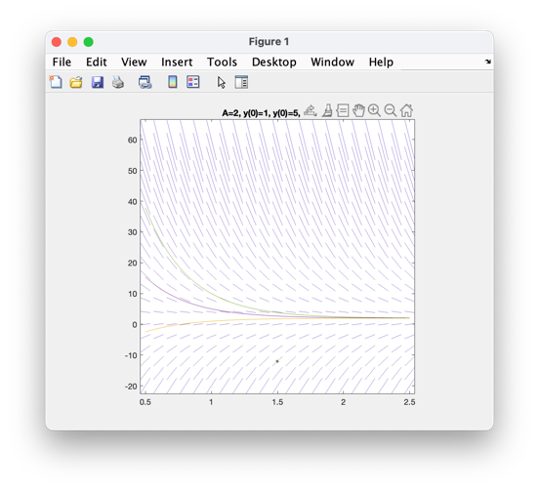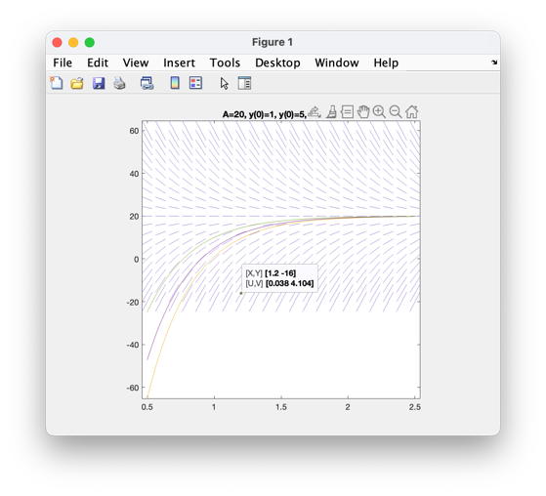

The variable A represents the equalized temperature of the temperature.

**Exercise 2.4**

1. choose the initial condition y(0) = =6
2. choose A to be the temperature of the fridge = 41
3. it takes the chicken a little over 1 hour (t = 1.05) to defrost
4. Roughly 40 minutes. (the chicken now defrosts at t=0.3)

**Exercise 2.5**

The slope of the line in the (xy) plane is defined by m = (dx/dt) / (dy/dt)

**Exercise 2.6**

**Exercise 2.7**

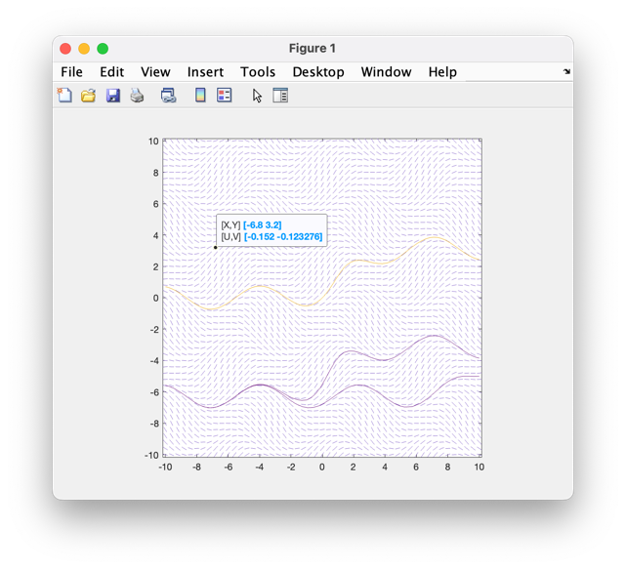

Choosing the same starting values for x(0) and y(0) yields the same curves

**Exercise 2.8**

